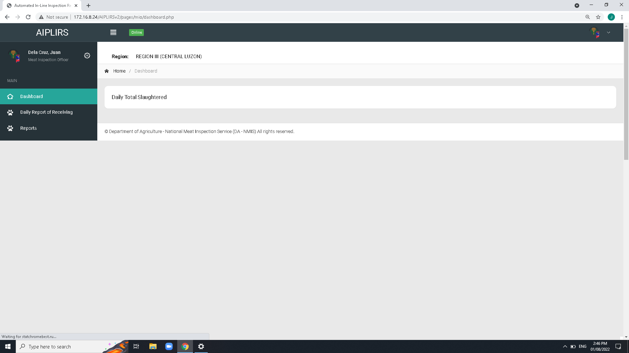

Create a summary card for the receiving, fit for slaughter, fit for human consumption

DASHBOARD CARDS : Status, Pending, Ongoing, completed

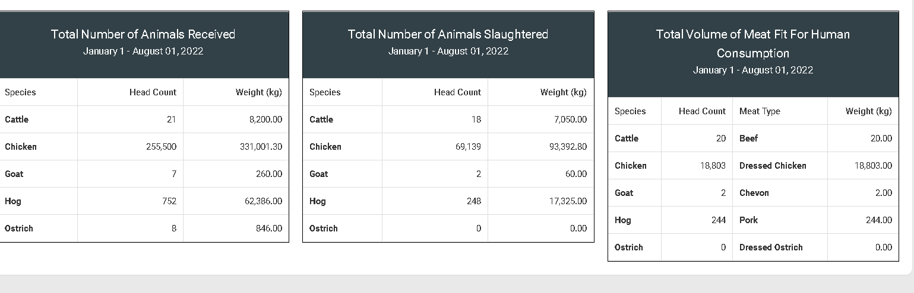

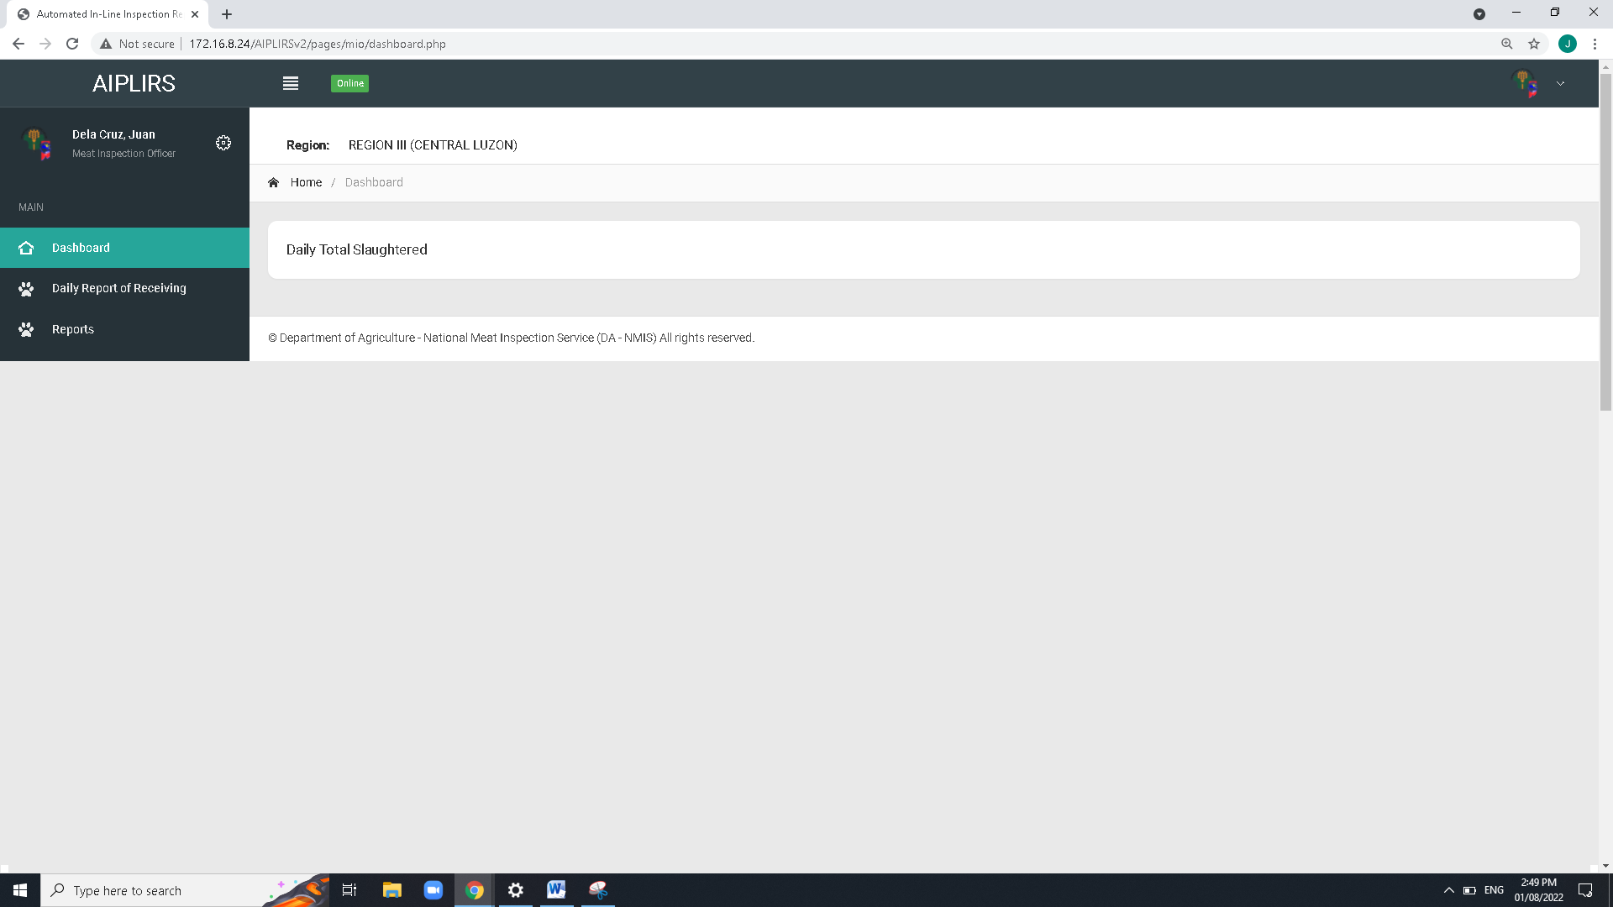

To be added on MIO account sidebar:

Output is the summary on the all Meat establishment assignment base on dates

(suggestions: tick boxes for the Current, previous)

Remove Navigation bar header and breadcrumbs on all pages

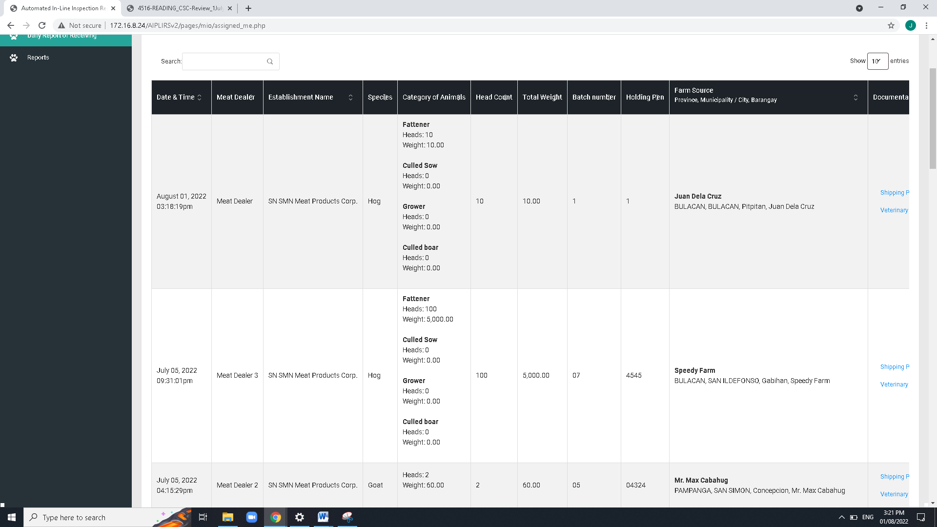

Make column sticky css from “date and time to species”

Change header title

Establishment to Meat establishment

Total weight to total weight(kg)

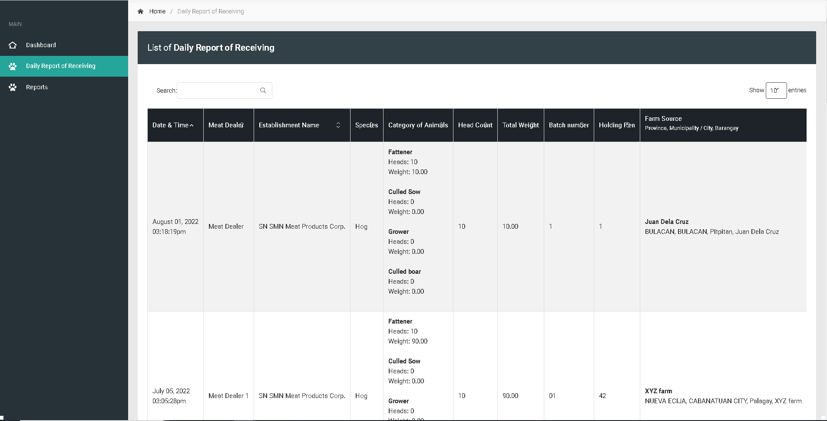

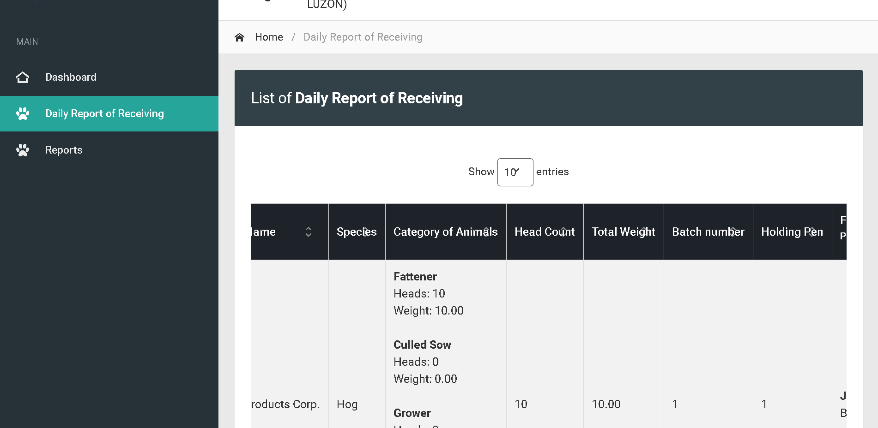

Change sidebar title to Daily Receiving of Animals

Bactch and holding pen : Text align center

For the column of head count and total weight make it text right

Change title to Daily Receiving of Animals

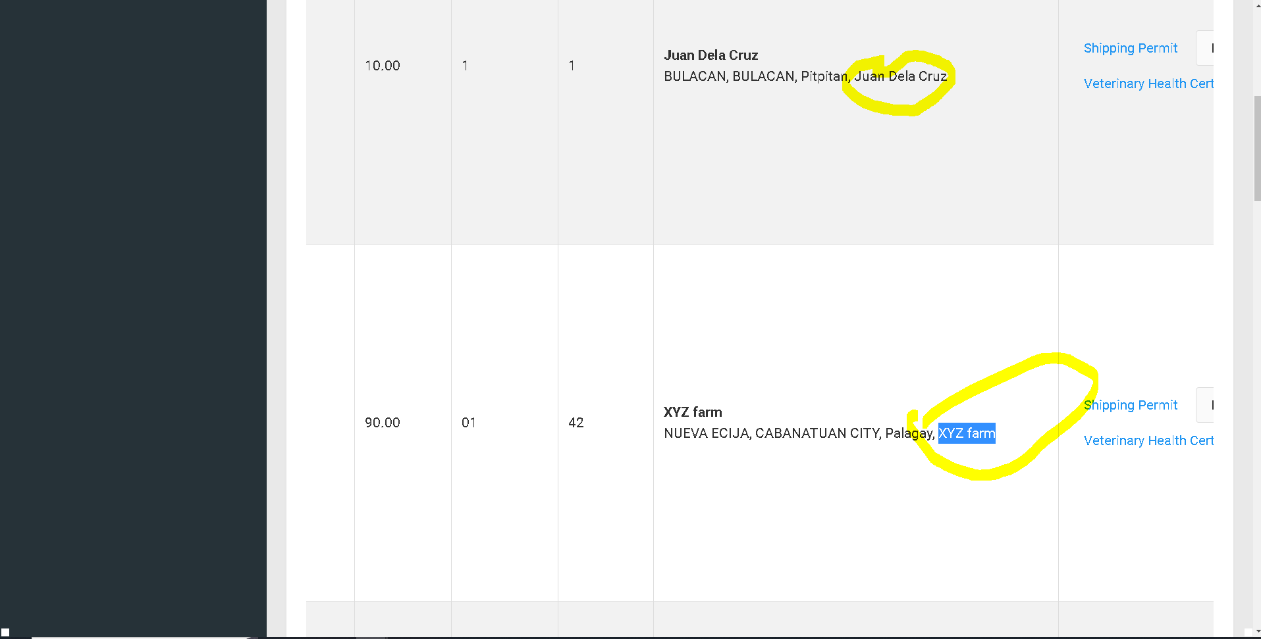

Farm source is visible on address

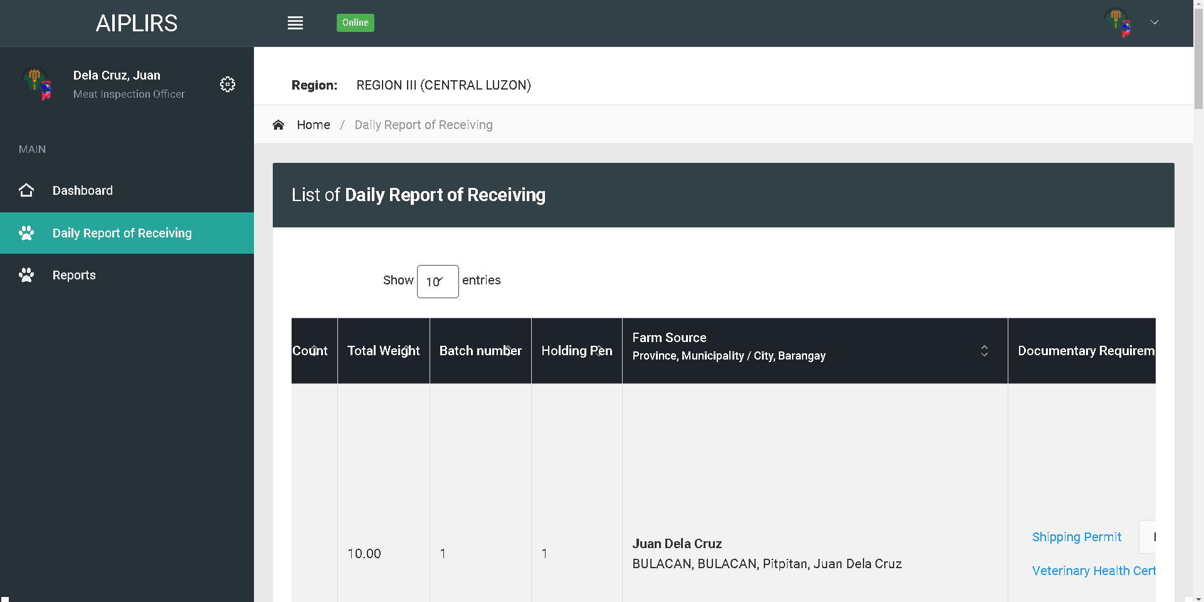

Change table header

Farm Source and Address

Remove indicator

Change address format to “barangay, city, province”

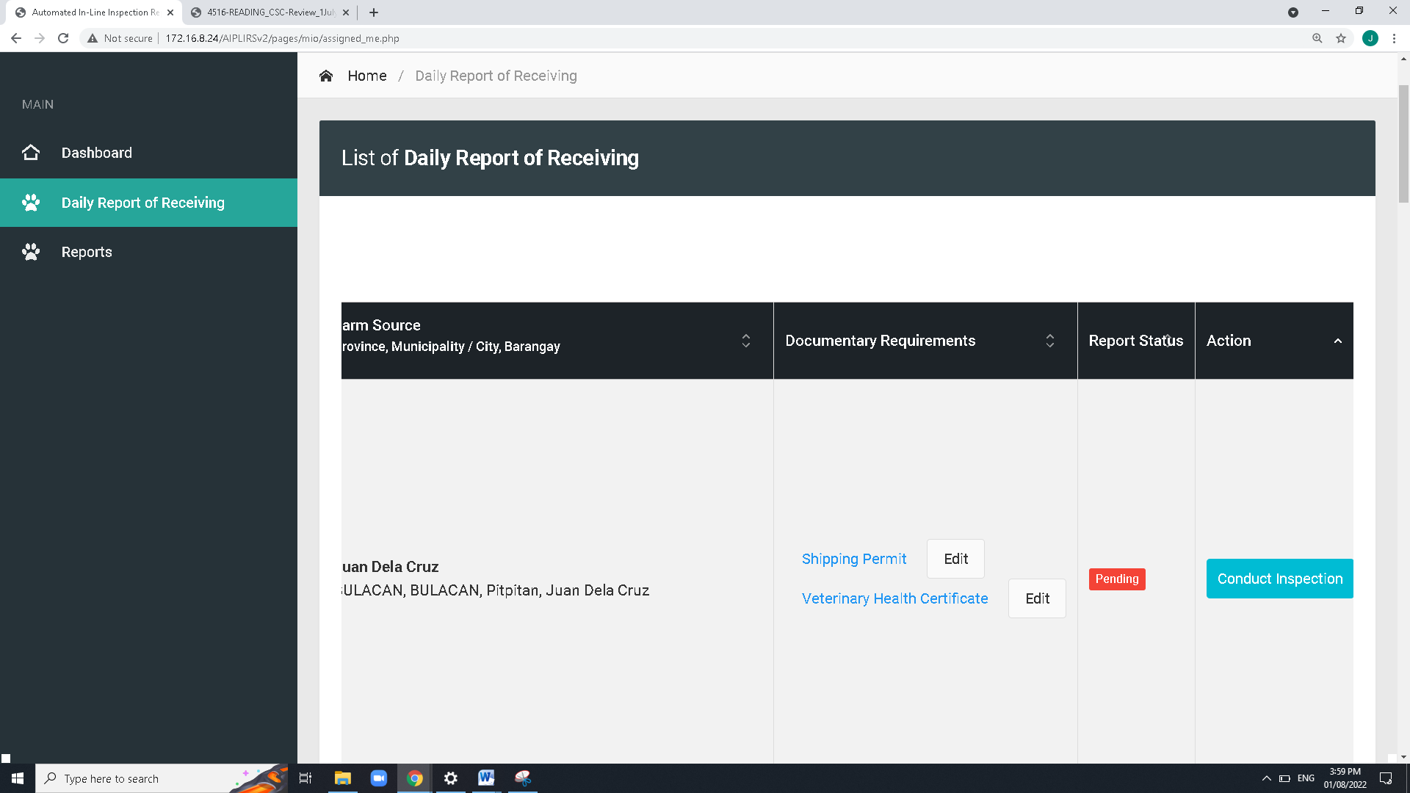

Add approve for the “Request to edit ” in the MIO button actions

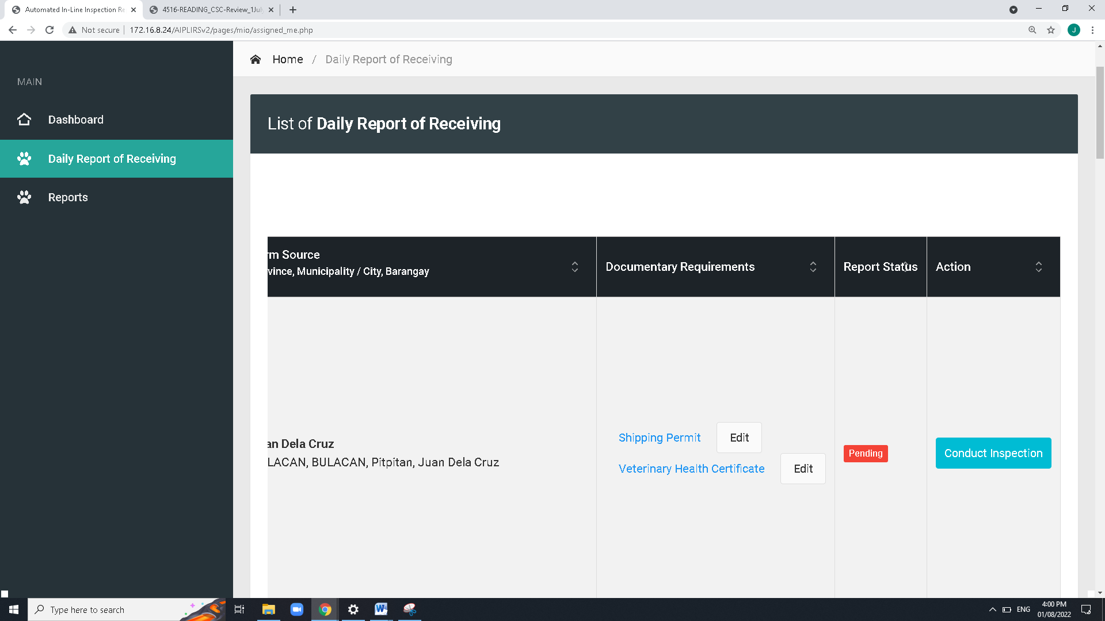

ME: Upload or Captured

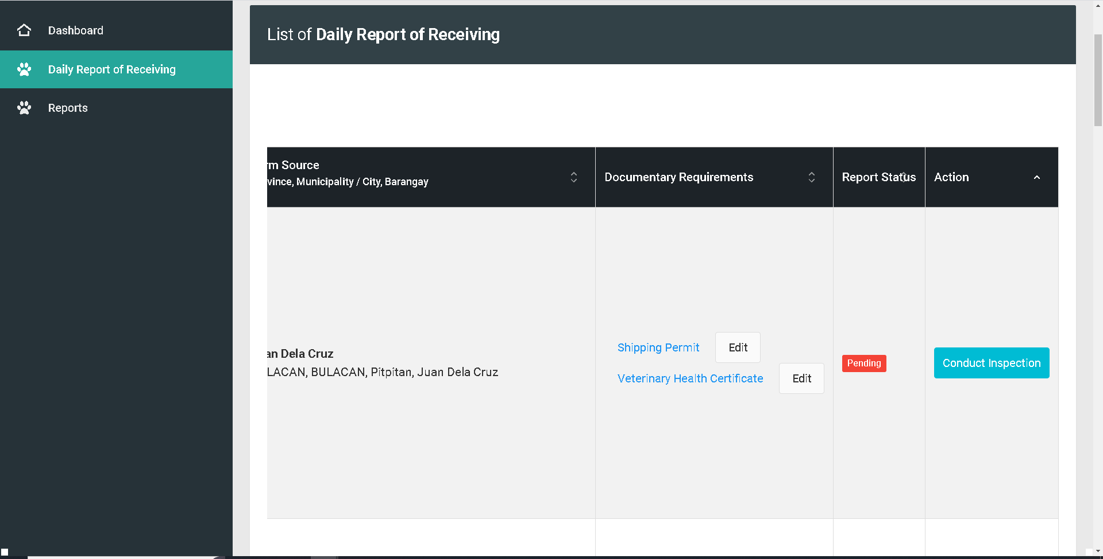

For the button of the of the shipping permit should change to Accept / Reject. Then system will notifiy the meat establishment for the edit of document

Change edit Accept / Reject

For the Revision

DRR & Meat Inspection Sta tus change the header

Remove action column meat dealer, total weight, batch numer, holding pen

Change positioning of after head count change header “drr details” button “td” view

Order of the table after drr details “DRR STATUS”, “INSPECTION STATUS”

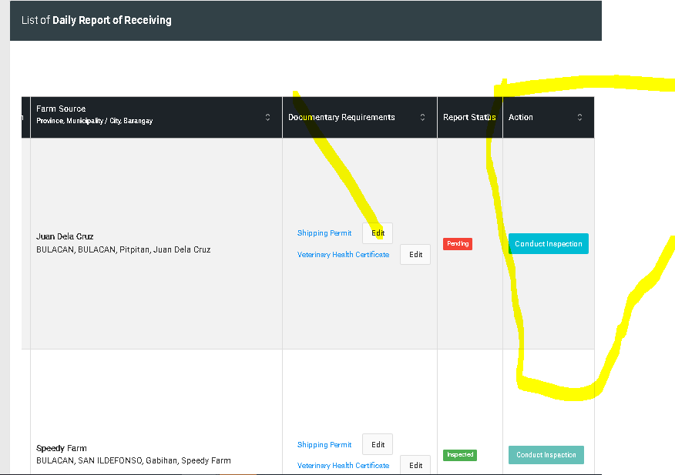

For edit change to for editing

remarks must be visible both MIO and ME

conduct inspection button change to proceed to inspection.

Create a popup viewing of details : action button change conduct inspection to proceed to inspection and button request to edit

Add a column for the “DRR status” and “Inspection report status”

remove edit button on documentary requirements

**Request to edit DRR** button:

for the reject button after clicking modal will appear and MIO will note the deficiencies or the correction of the data specially documentary req.

notification will appear on ME dashboard for the remarks,

**DRR status**: **pending** (request to edit), **For editing**, **Updated,**  **Completed**,

**Inspection report status**: **Pending**(upon checking Drr page), **On-going**(if DRR is approved color: orange), completed(Antemortem & postmortem conducted)

**Details of DRR page action**: **proceed to inspection**(DRR status will update to approved), **request to edit**

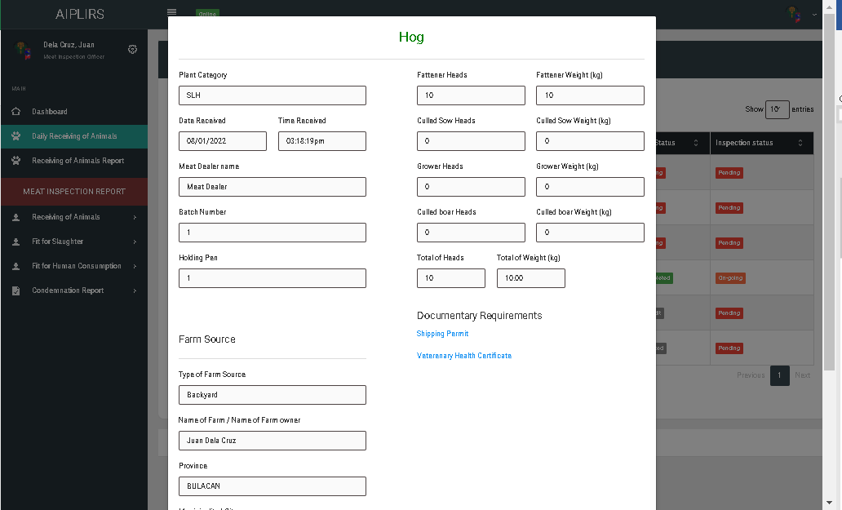

para sa farm source REMOVE spaces

Para sa batch at holding pen pagisahin sa isang row

Kapag zero ang value ihide ang datapalitan ang total head count remove of on total weight

Gawa ng modal para viewing of shipping permit

Plant category change to “type”

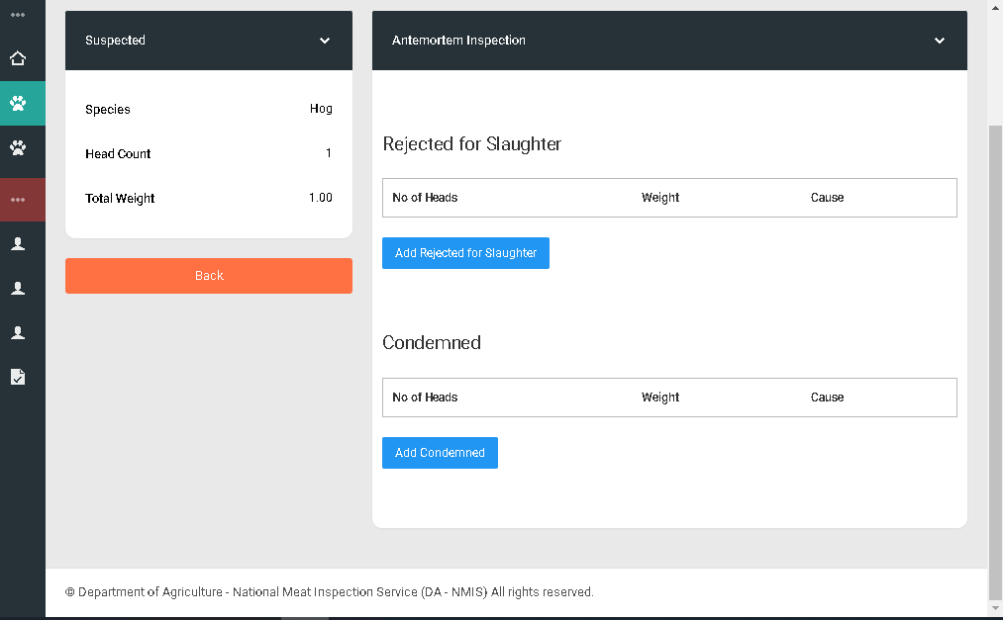

“Proceed to inspection button green” redirect to post-mortem inspection

“Passed for slaughter” add a row

Suggestion:” confirmatory result

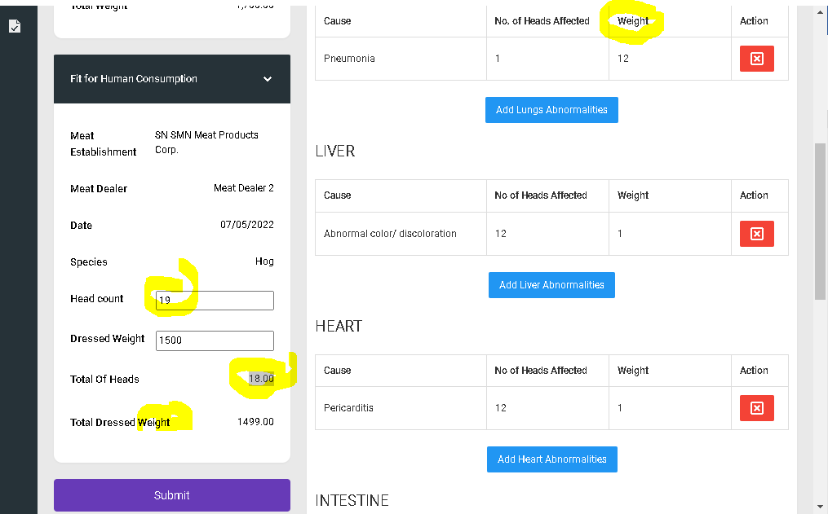

Change the title to” total head count”

Remove input

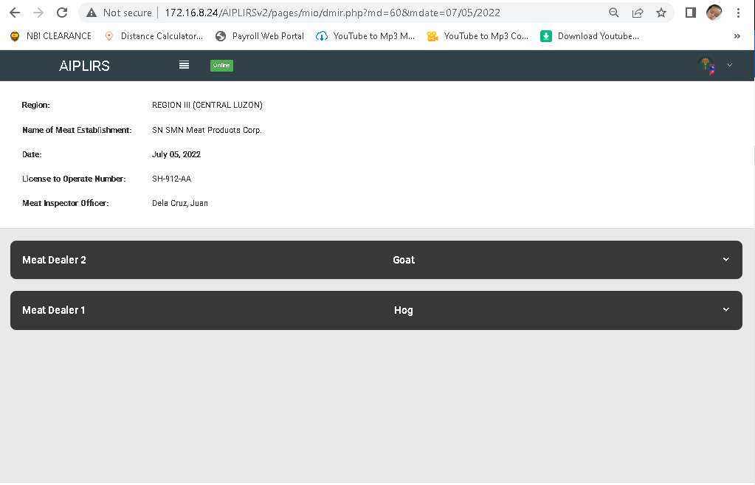

Date:

Region:

Meat Inspection Officer:

Segregate into 2 column

Meat establishment name

Lto number:

Sytem will be redirected to antemortem

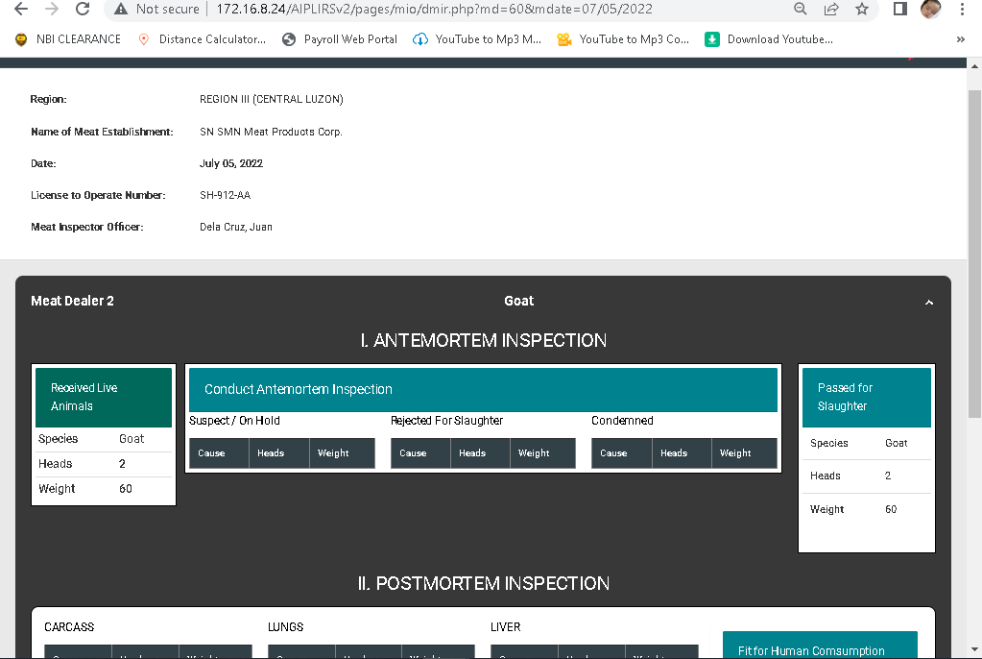

Add kg on the weight label

same with the head count

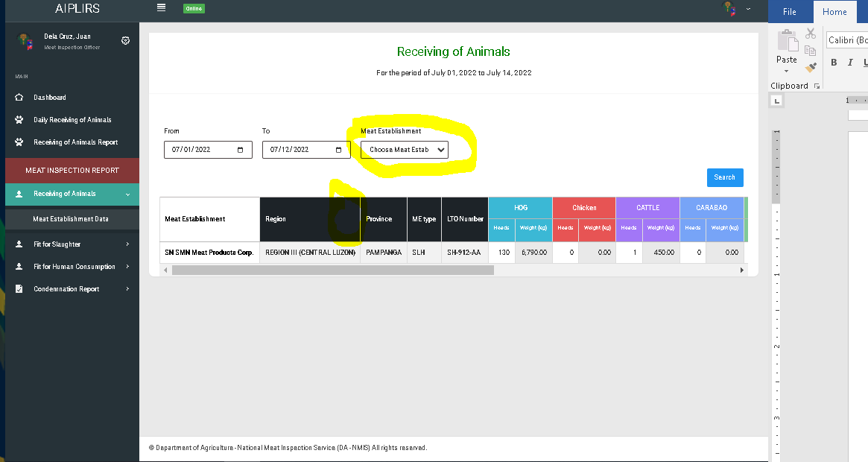

Add tick boxes on meat establishment option for filtering

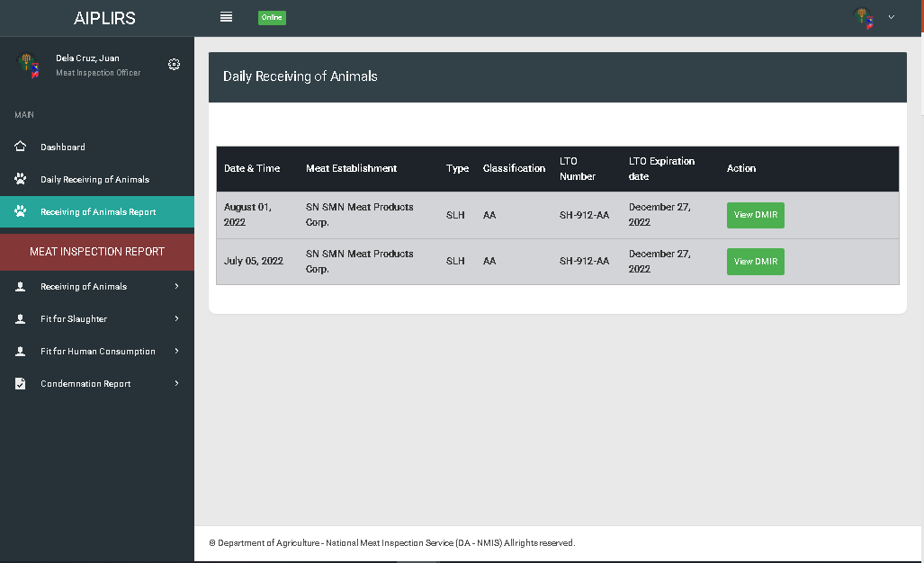

Change to received animals

Create a filtering form for the single date and redirect to page ((this link) remove page with the select me

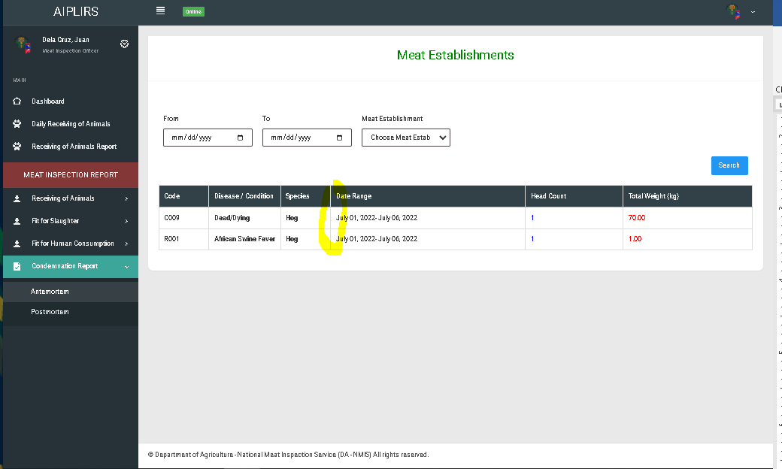

Add column for the judgement

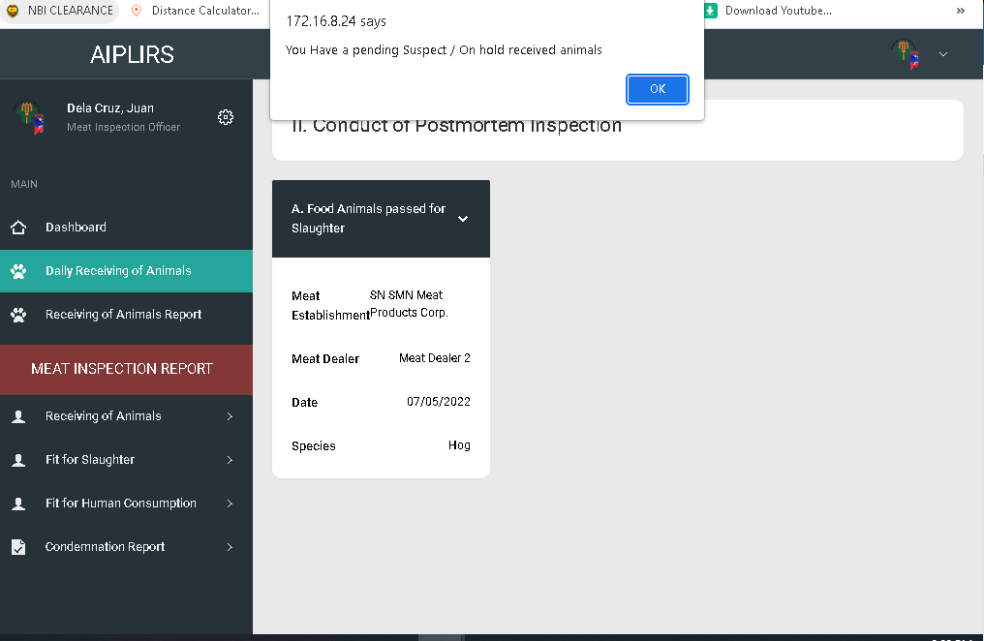

Sytem will be redirected to antemortem

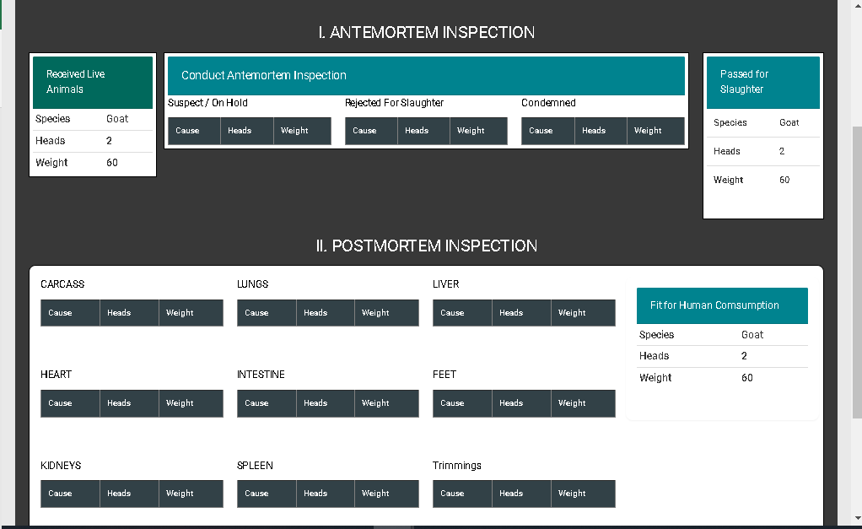

Choose a color for the back ground except black

All table header is on centered

Receiveing, pass for slauighte, fhc: total head count

Weight to Weight (kg)

**No. of Heads Affected postmortem inspection**

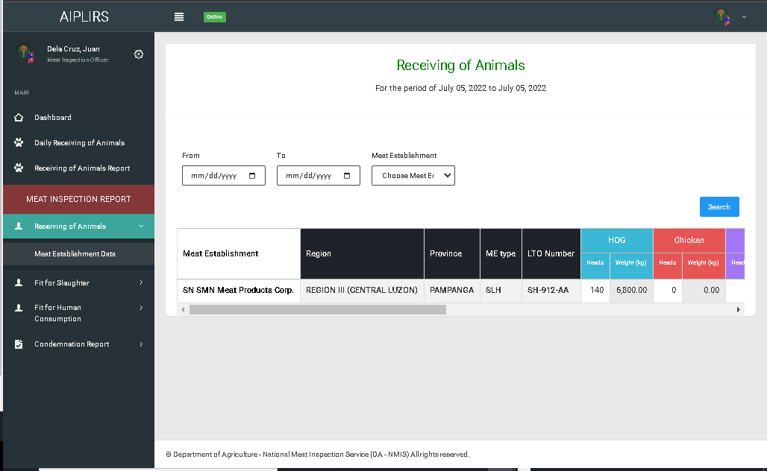

Make the font weight Into bold on all pages

REMOVE ALL COLUMN WITH 0 VALUE ON ALL SUMMARY USER ACCOUNTS(POSMD, POSMS, MIO, ME)

On MIO account remove meat inspection report sidebar header add “Summary of Meat Inspection Report

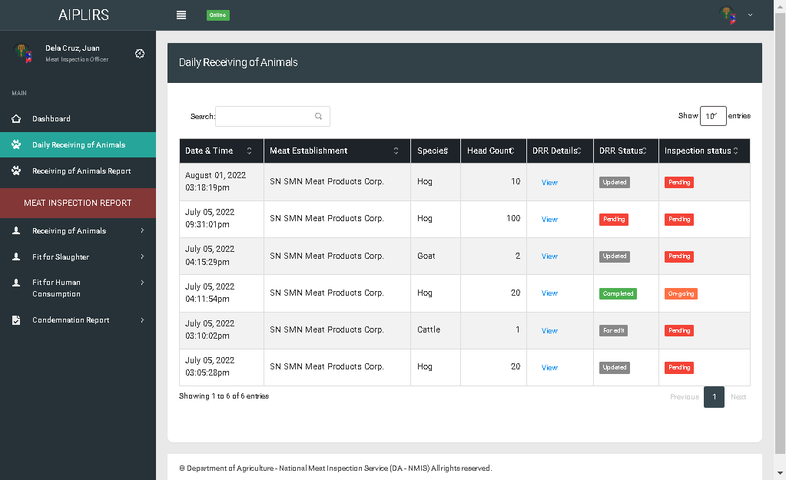

Daily Receiving of animals change to “DRR & Meat Inspection Status”

Receiving of Animals report chage to “Daily Meat Inspection Report”

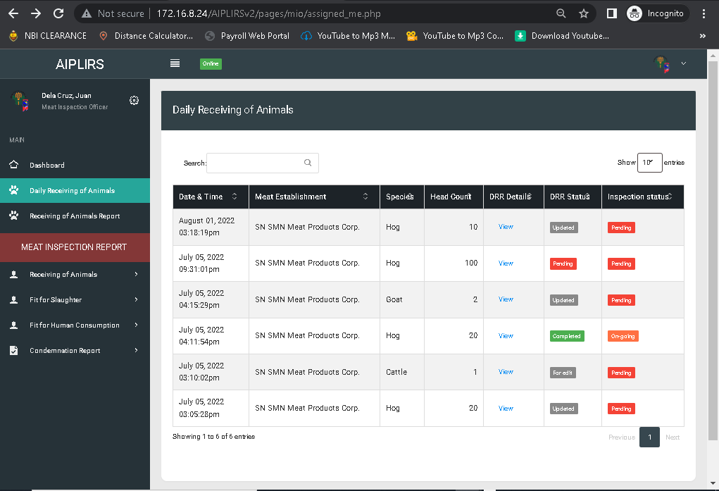

USER’S MANUAL: to be stated by details by details